## Instructions for Using download Script

### Downloading Logs

* Go to the BGS geoindex viewer at <https://mapapps2.bgs.ac.uk/geoindex/home.html>
* Select the boreholes under data tab to show boreholes
* Select your boreholes using the selection tool as shown below

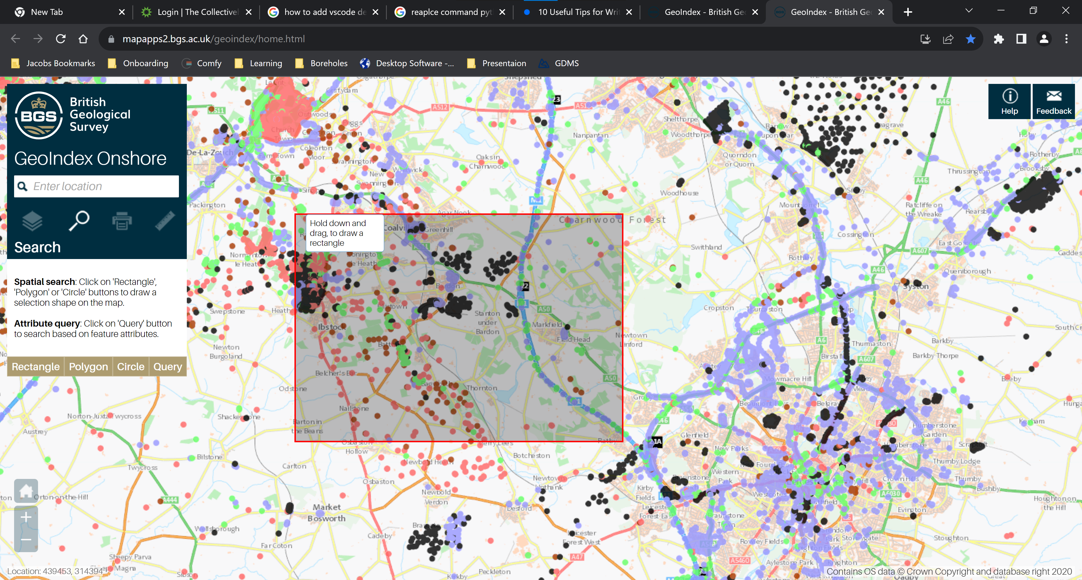

* Export the selection you desire, and ensure the file name is GeoIndexData.txt, the programme will not work if it is in any other form (such as GeoIndexData(2).txt)

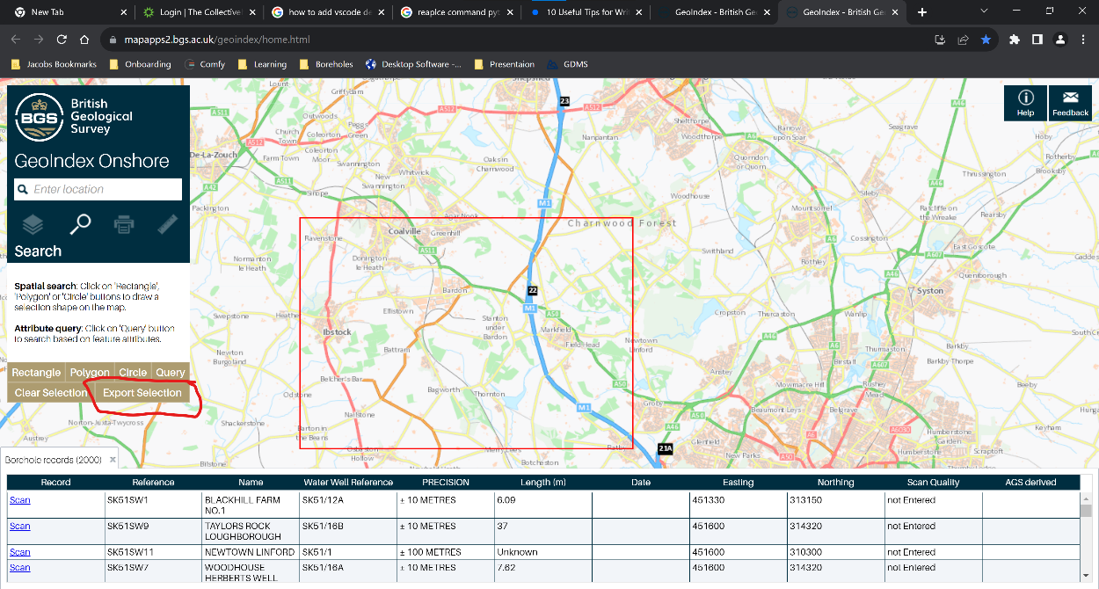

* Create a folder where you want to run the file, and add in the executeable file and the GeoIndexData.txt file. Ensure the folder name does not contain special characters or spaces. For example a bad title: M1 J20-30, a better example: M1_J20-30.

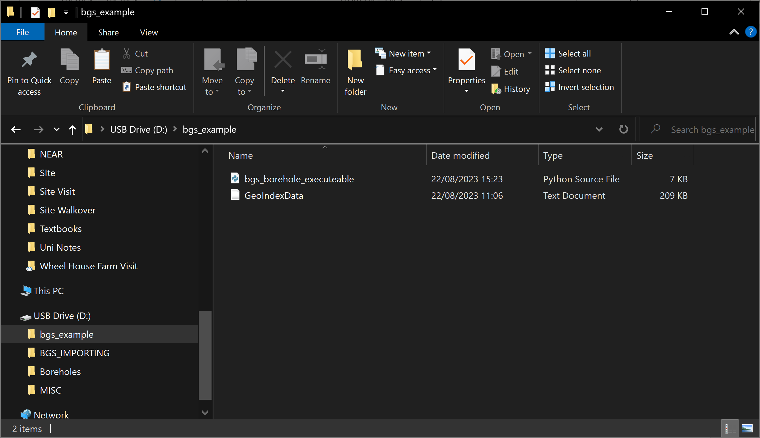

* Double click on the file and run it, and once it has been completed your folder should look like the image below

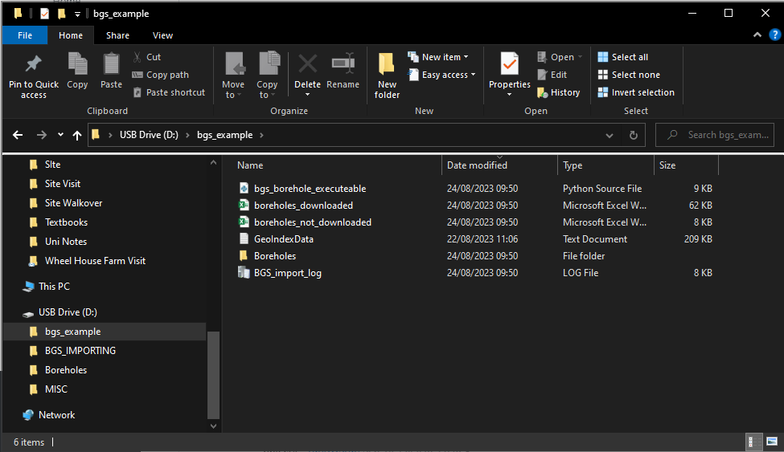

* The excel file titled boreholes_downloaded will show the info for the boreholes that have been downloaded by the program, and the boreholes_not_downloaded will show the ones that have not been downloaded (due to some error like them being confidential).
* The borehole files you want will be in the borehole folder
* If you want to run the program again for another set of boreholes, just replace the GeoIndexData file and run again